# 任务单 自定义对话框

## 演示任务

**设计自定义对话框，如下图所示，点击确定按钮可以在界面的结果显示栏显示“这是自定义对话框的操作”并关闭对话框；点击取消按钮直接关闭对话框。对话框的提示信息来自结果显示栏内显示的文本。**

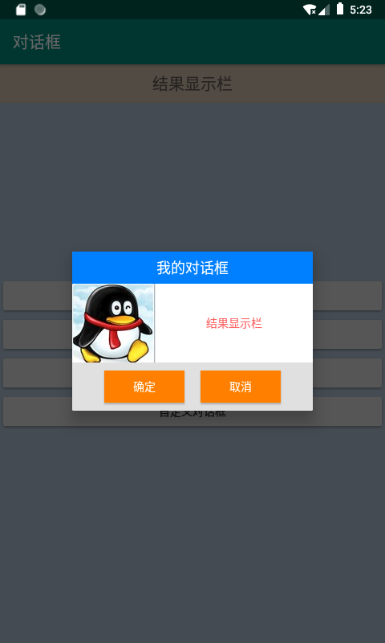

**=======提交规范=======**

**提交word文档，对应在每个任务下面添加程序代码，以姓名作为文件名。**

**截图：**

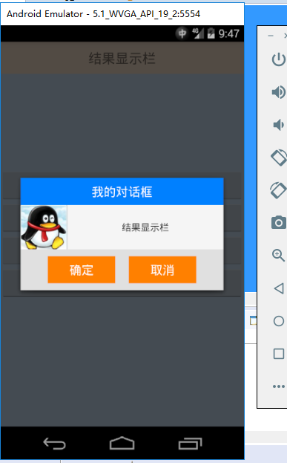

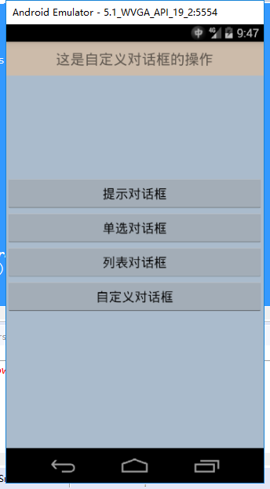

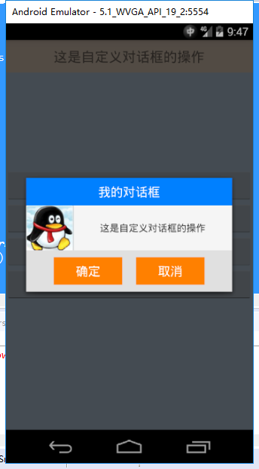

**代码：**

**Mydialog.java:**

**package** com.example.testdialogcus;

**import** android.app.Dialog;

**import** android.content.Context;

**import** android.os.Bundle;

**import** android.view.View;

**import** android.view.Window;

**import** android.widget.Button;

**import** android.widget.TextView;

**public** **class** Mydialog **extends** Dialog **implements** View.OnClickListener{

Button cusConfirm, cusCancel;

**private** TextView tvResult, tvMsg;

**private** String msg;

**public** Mydialog(Context context, View view, String msg) {

**super**(context);

// **TODO** Auto-generated constructor stub

tvResult = (TextView)view;

**this**.msg = msg;

}

@Override

**protected** **void** onCreate(Bundle savedInstanceState) {

// **TODO** Auto-generated method stub

**super**.onCreate(savedInstanceState);

requestWindowFeature(Window.***FEATURE_NO_TITLE***);

setContentView(R.layout.***dialog_cus***);

tvMsg = (TextView)findViewById(R.id.***cus_tvmsg***);

cusConfirm = (Button)findViewById(R.id.***cus_confirm***);

cusCancel = (Button)findViewById(R.id.***cus_cancel***);

cusConfirm.setOnClickListener(**this**);

cusCancel.setOnClickListener(**this**);

tvMsg.setText(msg);

}

@Override

**public** **void** onClick(View arg0) {

**switch** (arg0.getId()) {

**case** R.id.***cus_confirm***:

tvResult.setText("这是自定义对话框的操作");

dismiss();

**break**;

**case** R.id.***cus_cancel***:

dismiss();

**break**;

**default**:

**break**;

}

}

}

**MainActivity.java**

**package** com.example.testdialogcus;

**import** android.app.Activity;

**import** android.os.Bundle;

**import** android.view.View;

**import** android.widget.Button;

**import** android.widget.TextView;

**public** **class** MainActivity **extends** Activity **implements** View.OnClickListener {

**private** Button btnAlert,btnSingle,btnList,btnDiy;

**private** TextView tvShow;

@Override

**protected** **void** onCreate(Bundle savedInstanceState) {

**super**.onCreate(savedInstanceState);

setContentView(R.layout.***activity_main***);

initView();

}

**private** **void** initView(){

btnAlert=findViewById(R.id.***btn_alert***);

btnSingle=findViewById(R.id.***btn_single***);

btnList=findViewById(R.id.***btn_list***);

btnDiy=findViewById(R.id.***btn_diy***);

tvShow=findViewById(R.id.***tv_show***);

btnAlert.setOnClickListener(**this**);

btnSingle.setOnClickListener(**this**);

btnList.setOnClickListener(**this**);

btnDiy.setOnClickListener(**this**);

}

@Override

**public** **void** onClick(View v) {

**switch** (v.getId()){

**case** R.id.***btn_alert***:

**break**;

**case** R.id.***btn_single***:

**break**;

**case** R.id.***btn_list***:

**break**;

**case** R.id.***btn_diy***:

Mydialog myd = **new** Mydialog(**this**, tvShow, tvShow.getText().toString());

myd.show();

**break**;

}

}

}

dialog_cus.xml:

<?xml version=*"1.0"* encoding=*"utf-8"*?>

<LinearLayout xmlns:android=*"http://schemas.android.com/apk/res/android"*

android:layout_width=*"300dp"*

android:layout_height=*"wrap_content"*

android:orientation=*"vertical"* >

<TextView

android:layout_width=*"match_parent"*

android:layout_height=*"40dp"*

android:text=*"我的对话框"*

android:background=*"#0080ff"*

android:gravity=*"center"*

android:textSize=*"18sp"*

android:textColor=*"#ffffff"*/>

<LinearLayout

android:layout_width=*"match_parent"*

android:layout_height=*"wrap_content"*>

<ImageView

android:layout_width=*"wrap_content"*

android:layout_height=*"wrap_content"*

android:src=*"@drawable/qq2"*/>

<TextView

android:id=*"@+id/cus_tvmsg"*

android:layout_width=*"match_parent"*

android:layout_height=*"match_parent"*

android:gravity=*"center"*/>

</LinearLayout>

<LinearLayout

android:layout_width=*"match_parent"*

android:layout_height=*"60dp"*

android:background=*"#e0e0e0"*

android:gravity=*"center"*>

<Button

android:id=*"@+id/cus_confirm"*

android:layout_width=*"100dp"*

android:layout_height=*"40dp"*

android:background=*"#ff8000"*

android:text=*"确定"*

android:textColor=*"#ffffff"*/>

<Button

android:id=*"@+id/cus_cancel"*

android:layout_width=*"100dp"*

android:layout_height=*"40dp"*

android:background=*"#ff8000"*

android:text=*"取消"*

android:textColor=*"#ffffff"*

android:layout_marginLeft=*"20dp"*/>

</LinearLayout>

</LinearLayout>

activity_main.xml:

<?xml version=*"1.0"* encoding=*"utf-8"*?>

<FrameLayout xmlns:android=*"http://schemas.android.com/apk/res/android"*

xmlns:app=*"http://schemas.android.com/apk/res-auto"*

xmlns:tools=*"http://schemas.android.com/tools"*

android:layout_width=*"match_parent"*

android:layout_height=*"match_parent"*

android:background=*"#aabbcc"*

tools:context=*".MainActivity"*>

<TextView

android:id=*"@+id/tv_show"*

android:layout_width=*"match_parent"*

android:layout_height=*"wrap_content"*

android:background=*"#ccbbaa"*

android:gravity=*"center"*

android:text=*"结果显示栏"*

android:textSize=*"20sp"*

android:padding=*"10dp"*/>

<LinearLayout

android:layout_width=*"match_parent"*

android:layout_height=*"wrap_content"*

android:orientation=*"vertical"*

android:layout_gravity=*"center"*>

<Button

android:id=*"@+id/btn_alert"*

android:layout_width=*"match_parent"*

android:layout_height=*"wrap_content"*

android:text=*"提示对话框"* />

<Button

android:id=*"@+id/btn_single"*

android:layout_width=*"match_parent"*

android:layout_height=*"wrap_content"*

android:text=*"单选对话框"* />

<Button

android:id=*"@+id/btn_list"*

android:layout_width=*"match_parent"*

android:layout_height=*"wrap_content"*

android:text=*"列表对话框"*/>

<Button

android:id=*"@+id/btn_diy"*

android:layout_width=*"match_parent"*

android:layout_height=*"wrap_content"*

android:text=*"自定义对话框"*/>

</LinearLayout>

</FrameLayout>